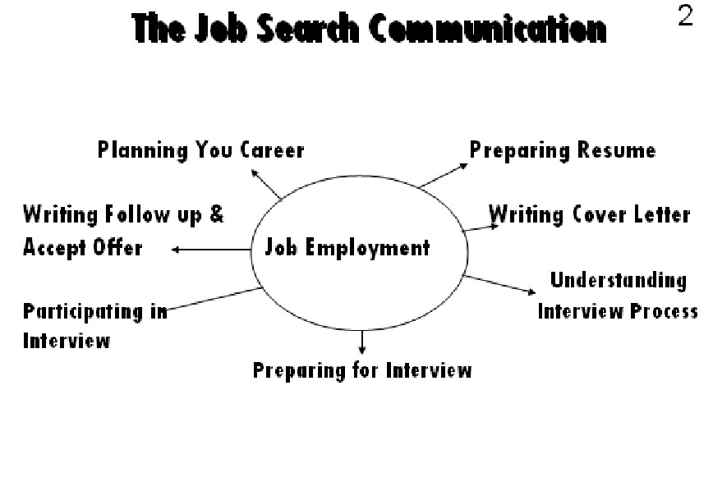LESSON 31
JOB SEARCH AND EMPLOYMENT
Outline:
The Job Search Communication Hiring Practices

For most business students, one of the most important communication tasks is preparing your resume. This document will represent you in offices you have never seen. The resume is just one aspect of a complete communication package that everyone must put together before he or she enters the business world. This package should also include a healthy amount of career planning and self-assessment before you even start thinking about a resume. In addition, after you have written a resume you need to think about writing cover letters, preparing yourself for interviews, and planning strategies for follow up interview with letters and telephone calls. This job-search communication package ends up looking very much like the following figure.

The Job Search Communication

Plan Your Career
Before you can sell a product, you need to know what the product is all about. Similarly, before selling your expertise you need to know the following:

. 158

Understanding today’s Changing Workplace
Today, work place is influenced by numerous forces such as globalization, advancing technology, information overload, grown diversity, and team based organizations. Certain other issue such as corporate downsizing, cost-cutting initiatives growing dependency on flexible employment techniques such as outsourcing and increasing entrepreneur are fast influencing the workplace.
How Changing Workplace Affects Job
Employment is more flexible. Today, lifelong employees are less in number, only, temporary workers & consultants are working project by project basis.
Hiring Practices
What today’s Employers Seek in job Applicants

Today Employers are looking for people who are:
Able and willing to adapt to diverse situation Are unafraid to change
Ready to learn on the job
Are sensitive to cultural differences

In fact, your chances of being hired are better if you've studied abroad or learned another
language.

Setting Realistic Objectives
How then do you begin assessing what you have to offer and then putting together a convincing sales pitch?
You cannot expect to be managing a major corporation or earning 100,000/- Rs.
Similarly, you cannot expect to do some petty job. This is a phase of self-assessment
process. Before selling a product know what that product is all about. So most of the
experts will tell you that the first thing you need to do is to set realistic objective for
yourself.
Know your Major Strengths and Weaknesses
To begin setting objectives, you may want to ask yourself a series of questions to clarify
your thinking. These may be questions about your own strengths and weaknesses,
questions about you goals, or a realistic appraisal of your abilities. Let's look at some
issues you will always want to consider during this phase of self-assessment process.
• What have you done at school?
• Were you good with number?
• Can you get along with people?
• Are there any Gaps in your work history?
• Are you inexperience?
• Are you over-qualified?
• Do you have long term employment with one company or job termination in your
career?
Establish Some Goals
• What are your long & short term goals?
. 159

• How do you picture yourself as a successful person?

Envision the Ideal Day at Work
• Talk to people about your envisioned profession
• Read out various occupations
• Determine the specific compensation you expect. What do you hope to earn in
your first year? What kind of pay increase do you expect each year? Are you
willing to settle for less money in order to do something you really love?

Envision Size of Company & Location
Do you like the idea of working for a small organization? How can you make yourself more valuable to employers?
• Keep an employment portfolio
• Collect anything that shows your ability to perform
• Take interim assignment
• Do temporary or freelance work
• Work on polishing and upgrading your skill
• Join networks of professional colleagues & friends who can keep you up to date
with occupation and industry
Narrow Down the Field
Let’s look at the functional areas of business and their activities as first step in narrowing
the field.
Finances
Investment bank, commercial banks savings and loans corporation and brokerage houses
Accounting
Public account firms work as controllers or financial planners. Activities in these jobs
range from reviewing financial records or balance sheets to monitoring business plans.

Marketing & Sales
In marketing you want to go to a company that sells consumer products, industrial products, high-technologies.

